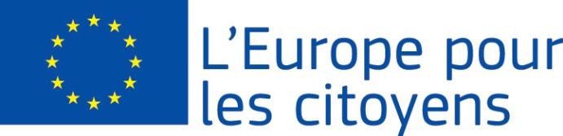
Európa pre občanov

Projekt“There is room for improvement!” financovala Európska únia v rámci programu
Európa pre občanov
Platí pre 2.1 "Opatrenie pre družobné partnerstvá miest"
Participation: the project enabled the meeting of 1293 citizens, from which 1000 came from the muicipality of Veľký Biel (Slovakia), 41 from Hajdúböszörmény(Hungary), 25 from Fadd (Hungary), 35 from Szany (Hungary), 25 from Pančevo (Serbia), 22 from Capizzi (Italy), 35 from Breznički Hum (Croatia),50 from Mad (Slovakia), 21 from Wörth am Rhein (Germany)

Place/dates: the meeting took place in Veľký Biel municipality, Slovakia from 26/08/2022 to 28/08/2022

Brief description:

On the first day, we presented the goals and values of the EU, we discussed with the citizens why the EU is important for its citizens. We continued with a lecture focused on help for people in difficult life situations and how the EU helps such people regardless of the family they were born into. We continued with an interesting discussion about discrimination, which we consider a negative factor that must be minimized. We also addressed the importance of democracy, volunteerism and, in another lecture, what activities the EU is involved in in the field of climate change. We ended the day with a visit to the fishing grounds - a 16 ha gravel pit in the territory of Veľký Biel. Thanks to the local organization of the Slovak Fishermen's Union, citizens had the opportunity to see different types of fish, and participants had the opportunity to enjoy recreation or try sport fishing and learn something about the care of the water area and its surroundings, as well as conduct a dialogue with each other.

The second day represented the recollection of unforgettable memories of the EU and at the same time focusing on the discussion about the future of the EU, in terms of the opinions expressed by the participants. The purpose of the other activities was to address social exclusion, cultural heritage values, a small international table tennis competition and the presentation of culture and customs using specific objects brought from each participating foreign municipality. We ended the second day with a wine tasting at the local Association of winegrowers and friends of wine in Veľky Biel.

We started the last day with a holy mass and a visit to the monument of the largest Baroque mansion from 1725. The day further offered useful lectures, gastronomy, discussions and workshops. The participants were enriched with new knowledge. Fun activities for children represented the creativity of the little ones within the theme of children's views on the EU. The children had the opportunity to create stickers, draw the flags of the participating nations on cups and build a tower, or paint the flags of the participating nations on their T-shirts and play a game of "sumo wrestlers" with the help of a pillow. The children could also take these objects to school and thus the dissemination of the results of the project was also spread in this way. Adults and seniors appreciated the relaxing yoga practice. After the end of the program, we evaluated the contribution of the project and mutual cooperation.

